Module 6: Portfolio Milestone

Risk Matrix

Since our blockchain project is still in its infancy there are some risks that could derail the system. Some of the potential risks include a halt on funding, gold plating, server malfunction, cyber attacks, and coworker issues at the workplace. In order to measure each potential risk, each risk has been placed into a risk matrix. The risk matrix allows them to be measured and sorted. Thus exposing the deadliest risk, the risk with minimal concern, and all the other risks in between.

According to our risk matrix the deadliest risk is gold plating. Gold plating is the deadliest risk because the project has already experienced it and has fallen a bit behind because of it. Therefore, going forward we need to be extremely cognisant of gold plating, in order to prevent any further delays. Even though gold plating is our primary risk there are still other risks that could bring a halt to our blockchain project.

One of our other main threats is a cyber security attack. Cyber security attacks can happen to any software platform and thus should be taken seriously. Therefore the developers need to make sure the platform is as secure as possible before the first deployment. Additionally, defense against a cyber security threat will be a primary part of maintaining the deployed version. Unfortunately, gold plating and cyber security threats are not the only risks associated with the project.

Other potential risks include halt on funding, server malfunction, and coworker issues in the workplace. According to the risk matrix, these risks rank lower than the previously stated two risks, however, they still need to be taken into consideration. Investors could stop funding the project, the servers could quit working, and/or there could be internal issues between co-workers. All of which would bring delays or completely derail the project.

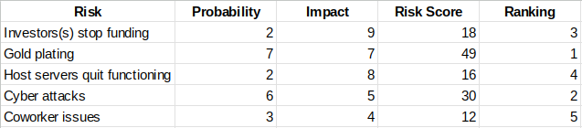

Risk Matrix